Types of Machine Learning Algorithms

🔹 1. Supervised Learning
👉 The model learns from labeled data (input + correct output already given)

✔ How it works:
- You provide X (input) and Y (output)
- Model learns mapping: X → Y

✔ Types:
- Regression → Output is continuous
Example: Predict salary
Algorithms:
  - Linear Regression
  - Polynomial Regression
- Classification → Output is categorical
Example: Spam or Not Spam
Algorithms:
  - Logistic Regression
  - K-Nearest Neighbors (KNN)
  - Decision Tree
  - Support Vector Machine (SVM)
  - Random Forest

2. Unsupervised Learning
👉 The model learns from unlabeled data (no output given)

✔ Goal:
- Find hidden patterns or structure in data

✔ Types:
- Clustering → Group similar data
Algorithms:
  - K-Means
  - Hierarchical Clustering
  - DBSCAN
- Association → Find relationships
Example: Market Basket Analysis
Algorithms:
  - Apriori
  - FP-Growth

✔ Example:
- Group customers based on buying behavior

Reinforcement Learning
👉 Model learns by trial and error

✔ How it works:
- Agent interacts with environment
- Gets reward or penalty
- Learns best actions over time

✔ Key Concepts:
- Agent
- Environment
- Reward
- Action

✔ Algorithms:
- Q-Learning
- Deep Q Networks (DQN)

✔ Example:
- Game playing (like chess, self-driving cars)
Type |  |  |  | Data Type |  |  |  |  |  | Goal |  |  |  |  |  | Example Use Case
Supervised Learning |  |  |  | Labeled |  |  |  |  |  | Predict output |  |  |  |  |  | House price prediction
Unsupervised Learning |  |  |  | Unlabeled |  |  |  |  |  | Find patterns |  |  |  |  |  | Customer segmentation
Semi-Supervised |  |  |  | Mixed |  |  |  |  |  | Improve learning |  |  |  |  |  | Image classification
Reinforcement Learning |  |  |  | Feedback-based |  |  |  |  |  | Maximize reward |  |  |  |  |  | Game AI
• Supervised → “Teacher is present”
• Unsupervised → “No teacher”
• Semi-supervised → “Few teachers”
• Reinforcement → “Learn from reward”

What is Regression and Classification?
Both Regression and Classification come under Supervised Learning, but they differ based on the type of output.

🔹 1. Regression
👉 Regression is used to predict continuous (numeric) values

✔ Output:
- Numbers (infinite possibilities)

✔ Examples:
- Predict house price (₹5,00,000, ₹10,00,000, etc.)
- Predict temperature
- Predict salary
Regression Equation (Example)
y=mx+b.

1. y (Dependent Variable)
- The output or predicted value
- Depends on x
- Example: Marks, Salary, Price

✔ 2. x (Independent Variable)
- The input feature
- What you control or measure
- Example: Study hours, Experience

✔ 3. m (Slope)
👉 Shows how much y changes when x changes
- If m is positive → line goes upward 📈
- If m is negative → line goes downward 📉

✔ Formula of slope:
m=Δx/Δy​
👉 Example:
If m = 10 → when x increases by 1, y increases by 10

Common Regression Algorithms:
- Linear Regression
- Polynomial Regression
Experience (Years) |  |  |  |  |  |  | Salary
1 |  |  |  |  |  |  | 20000
2 |  |  |  |  |  |  | 30000
Output is numeric → Regression

2. Classification
👉 Classification is used to predict categories (labels)

✔ Output:
- Discrete values (fixed classes)

✔ Examples:
- Spam / Not Spam
- Pass / Fail
- Disease: Yes / No

✔ Common Classification Algorithms:
- Logistic Regression
- K-Nearest Neighbors (KNN)
- Decision Tree
- Support Vector Machine (SVM)
- Random Forest

=>Linear Regression in Machine Learning (Detailed Explanation)
Linear Regression is one of the most basic and widely used algorithms in Supervised Machine Learning. It is used to predict a continuous (numeric) output based on one or more input features.

🔹 1. What is Linear Regression?
It models the relationship between:
- Independent variable (X) → input (e.g., study hours)
- Dependent variable (Y) → output (e.g., marks)
The goal is to find a straight line that best fits the data.

Equation of Linear Regression
Y=mx+b

Types of Linear Regression

✅ 1. Simple Linear Regression
- Only one input variable
- Example: Predict salary based on experience

✅ 2. Multiple Linear Regression
- More than one input variable
- Example: Predict house price using size, location, and number of rooms
Equation:
y=b0​+b1​x1​+b2​x2​+⋯+bn​xn​

How It Works (Concept)
The model finds the best line using Least Squares Method:
- It minimizes the error between actual and predicted values
Error = difference between actual and predicted values

Cost Function (Error Measurement)
MSE=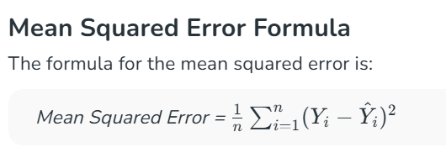
- n is the number of observations in the dataset.
- yi is the actual value of the observation.
- Y^iY^i​ is the predicted value of the ith observation.

- This is called Mean Squared Error (MSE)
- The goal is to minimize this value

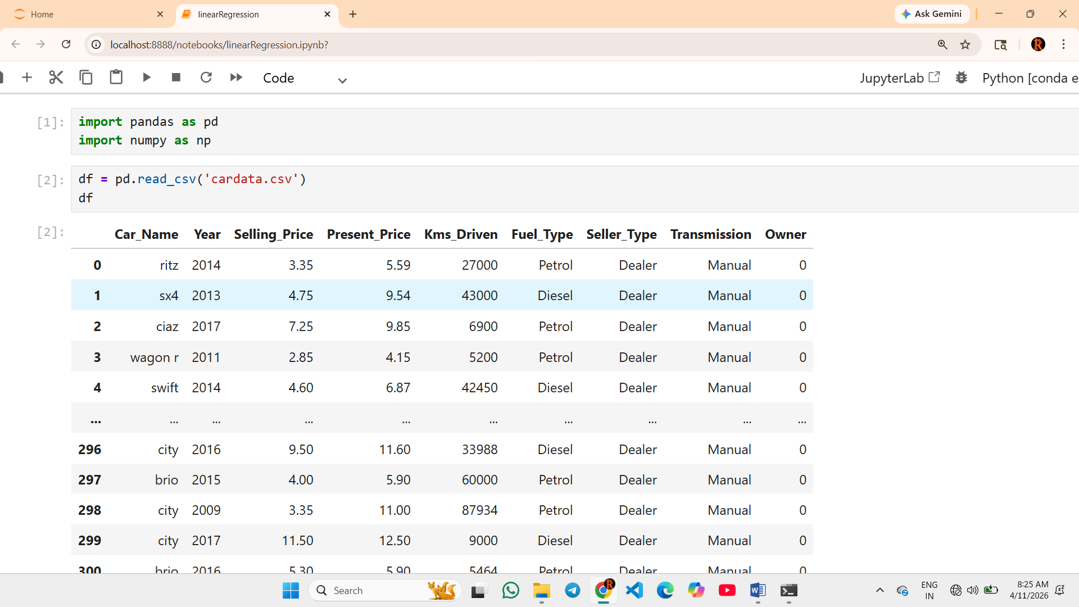
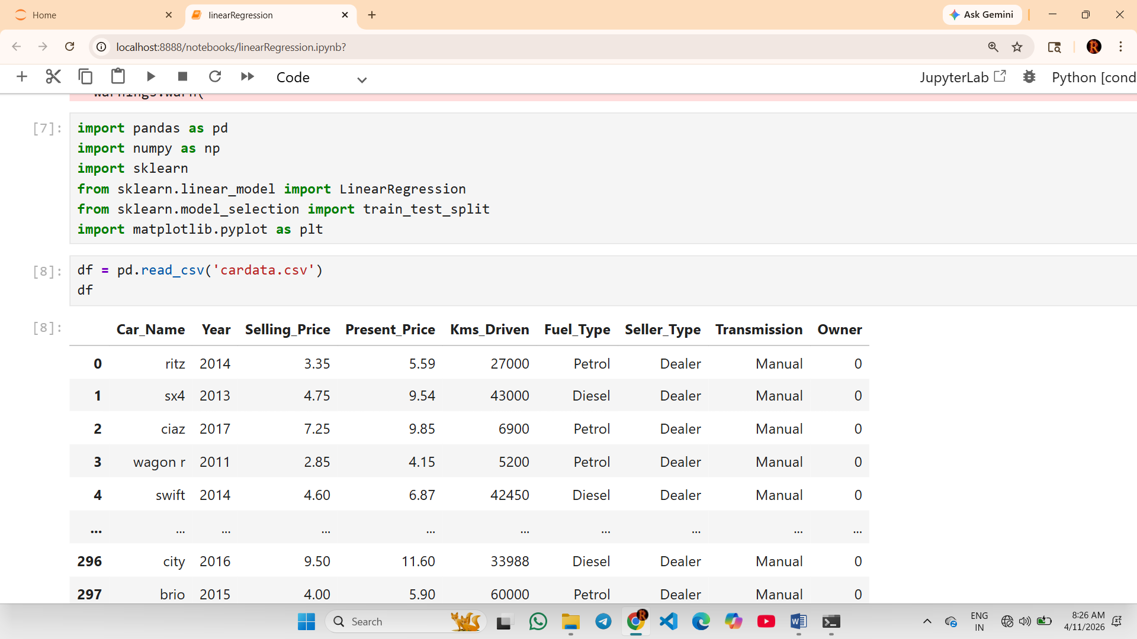

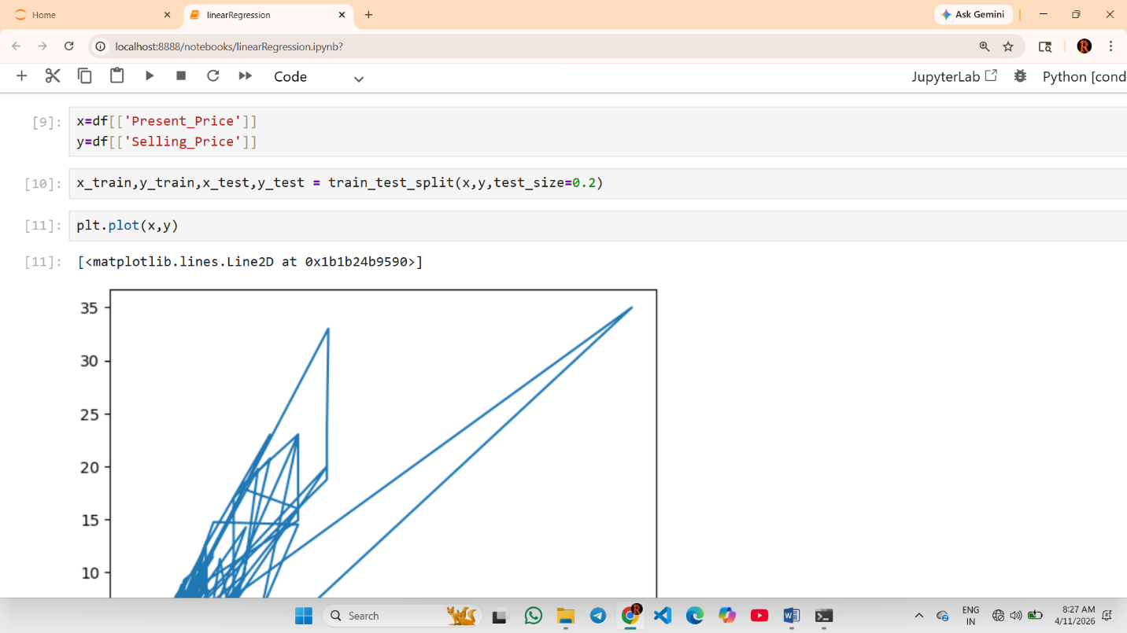
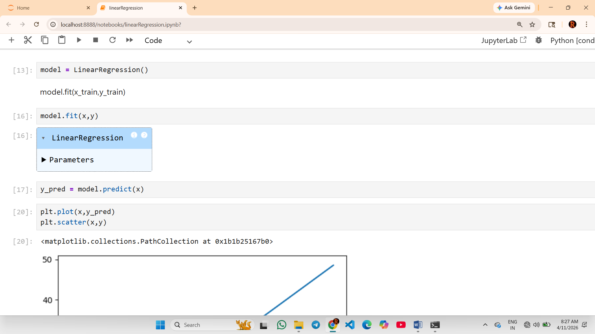
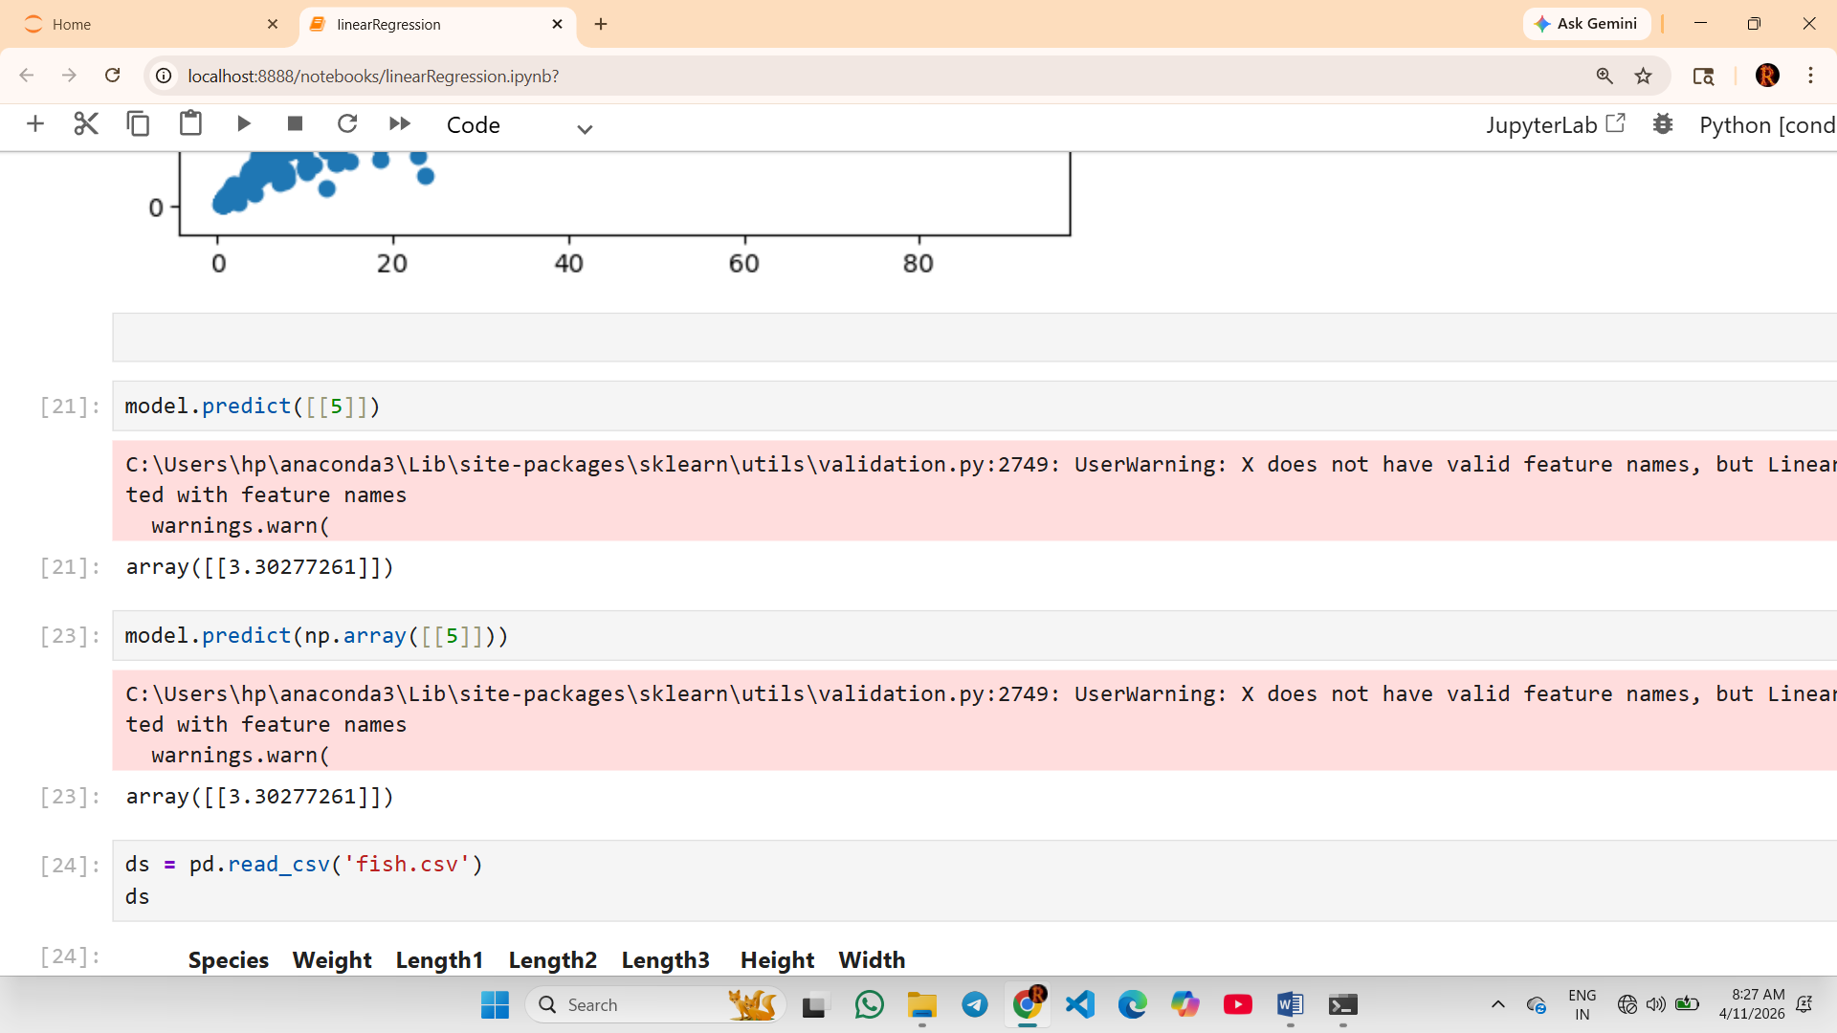

1. What is Multiple Linear Regression?
👉 It predicts a continuous value using multiple inputs (features)

✔ Example:
Predict house price based on:
- Size (sq ft)
- Number of rooms
- Location score

🔹 2. Equation of Multiple Linear Regression
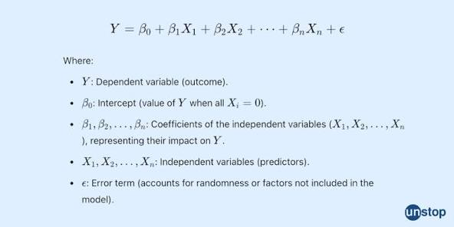

✔ Meaning:
- y → predicted output
- b₀ → intercept (bias)
- b₁, b₂, … bₙ → coefficients (weights)
- x₁, x₂, … xₙ → input features

🔹 3. How It Works
👉 The model finds the best combination of coefficients (b₁, b₂, …) such that:
- Predicted values are closest to actual values
- Error is minimized using Least Squares Method

1. What is Error?
👉 Error = difference between actual value (y) and predicted value (ŷ)
Error=y−y^\text{Error} = y - \hat{y}Error=y−y^​

🔹 2. Types of Error Metrics

🔸 1. Mean Absolute Error (MAE)


- yi​ :Actual value for the ith observation
- y^​: Calculated value for the i^{th} observation
- n: Total number of observations

✔ Explanation:
- Takes absolute difference (no negative values)
- Easy to understand
✔ Use:
- When all errors are equally important

🔸 2. Mean Squared Error (MSE)

✔ Explanation:


- Squares the error → penalizes large errors more

Root Mean Squared Error (RMSE)

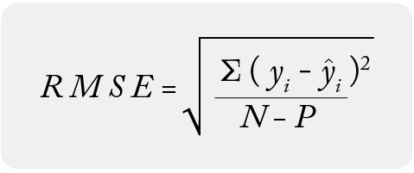
- yi is the actual value of the ith observation.
- ŷi is the predicted value for the ith observation.
- P is the number of the parameter estimated, including the constant.
- N is the number of observations.

✔ Explanation:
- Square root of MSE
- Same unit as original data

✔ Use:
- Most commonly used metric

🔸 4. R² Score (Coefficient of Determination)

✔ Explanation:
- Measures how well model fits data
- Value range:
  - 1 → perfect model
  - 0 → poor model

✔ Example:
- R² = 0.85 → model explains 85% variance
Metric |  |  |  | Meaning |  |  |  | Best Value
MAE |  |  |  | Avg error |  |  |  | Low
MSE |  |  |  | Penalizes big errors |  |  |  | Low
R² |  |  |  | Model accuracy |  |  |  | High

MULTI-LINEAR REGRESSION EXAMPLE WITH ‘FISH.CSV’ DATASET
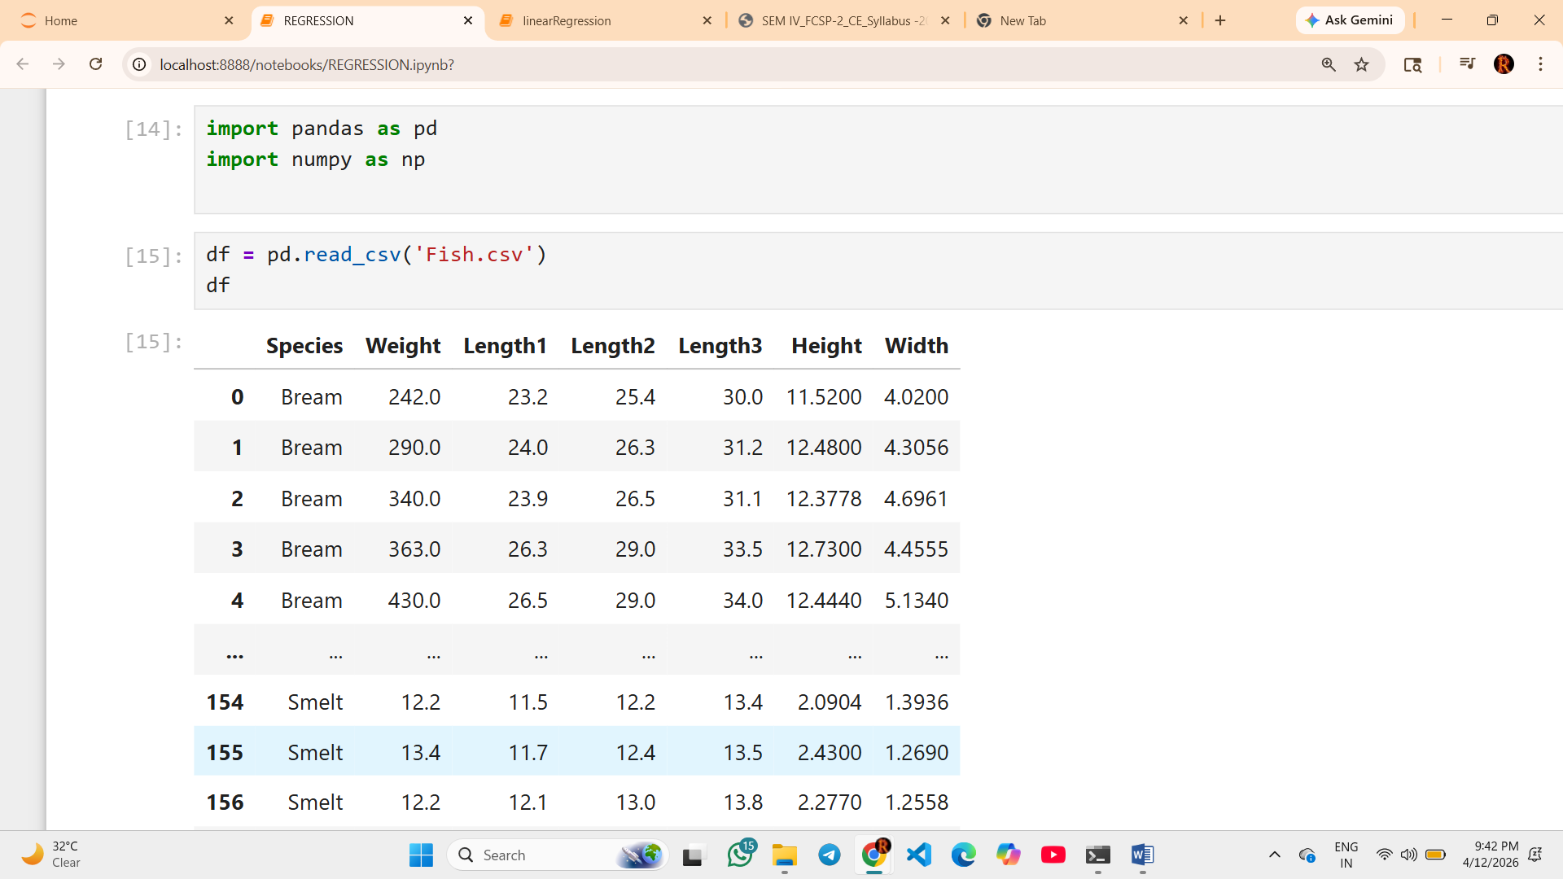
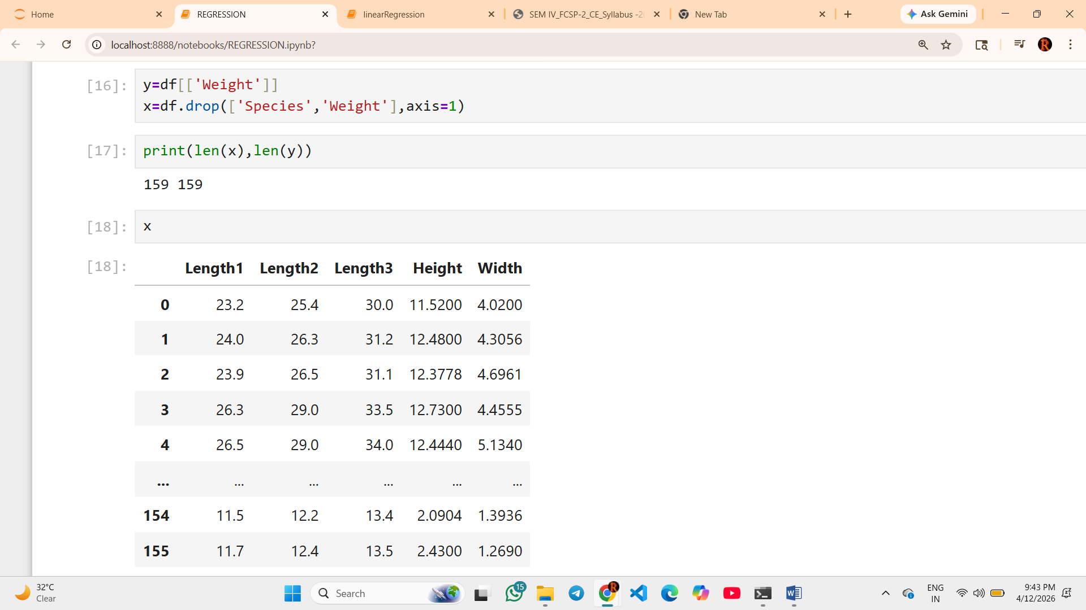
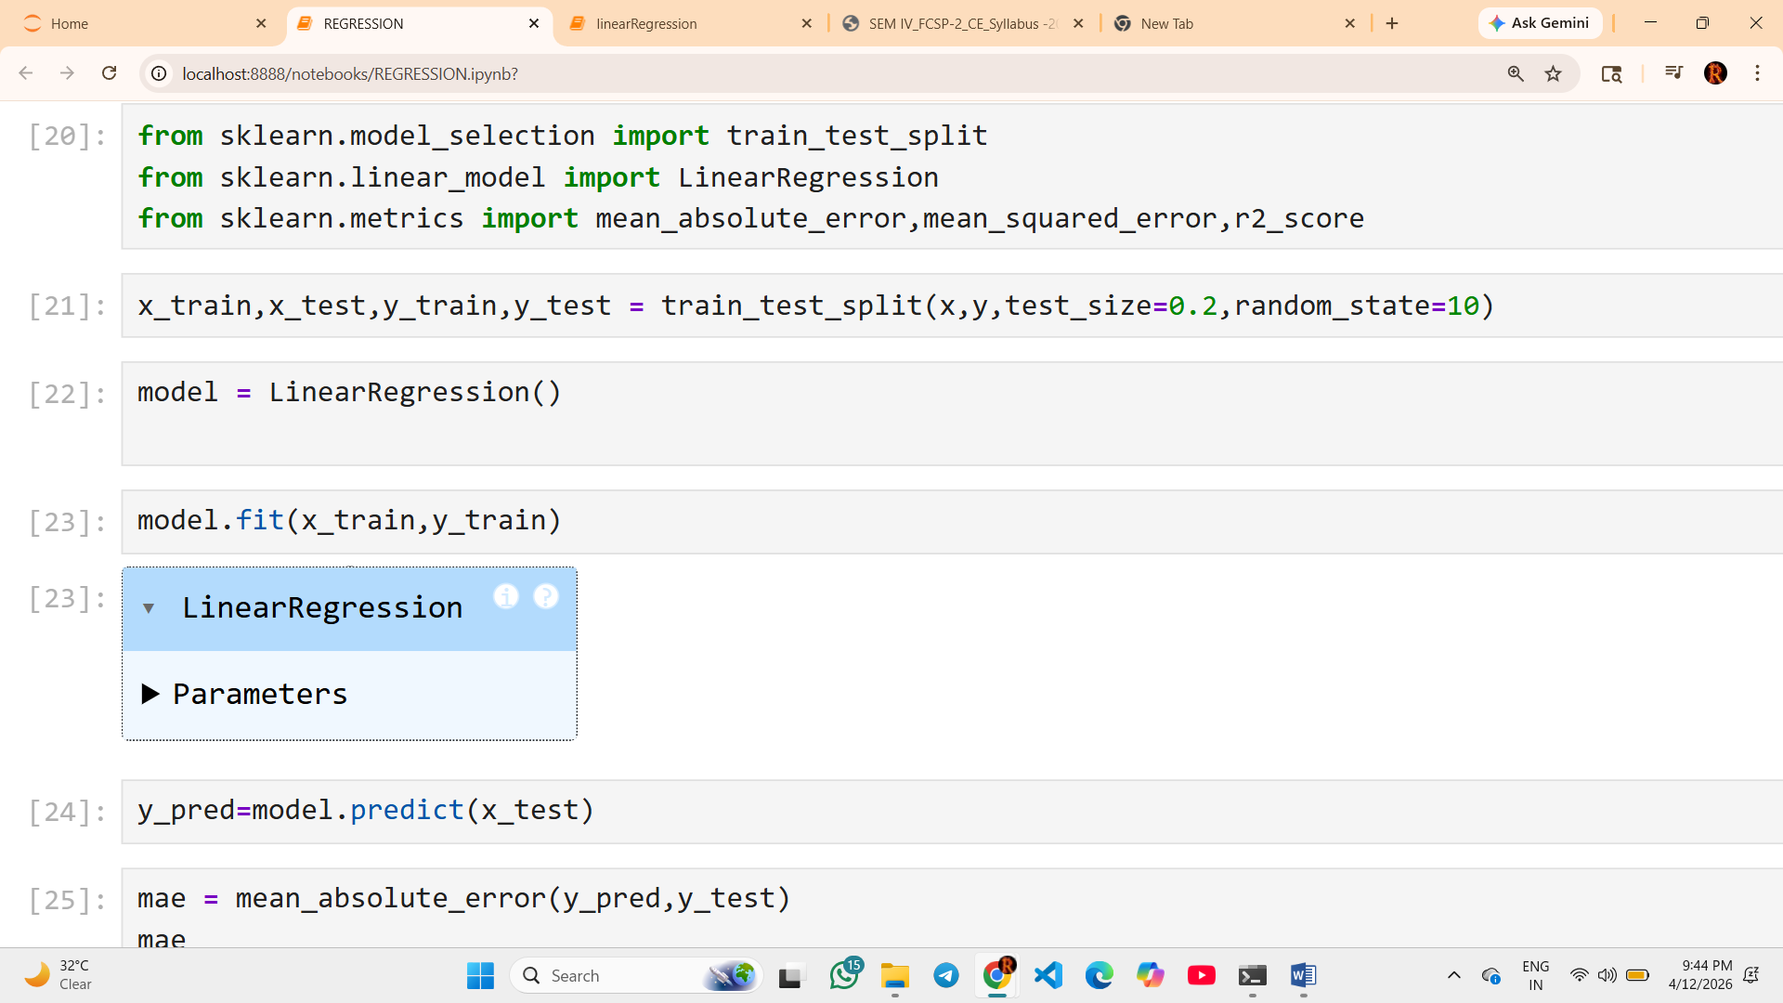
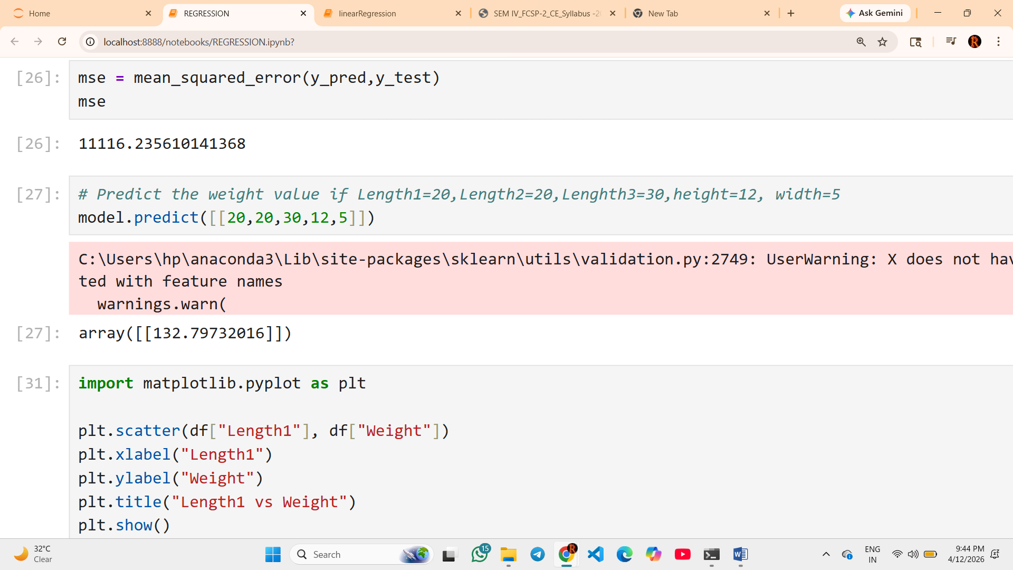
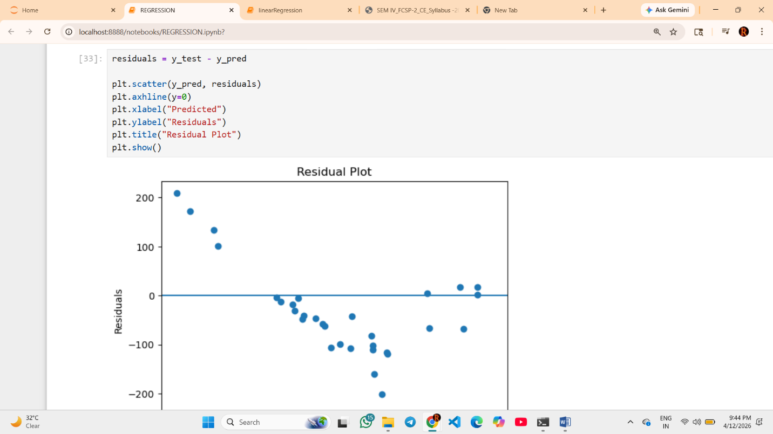
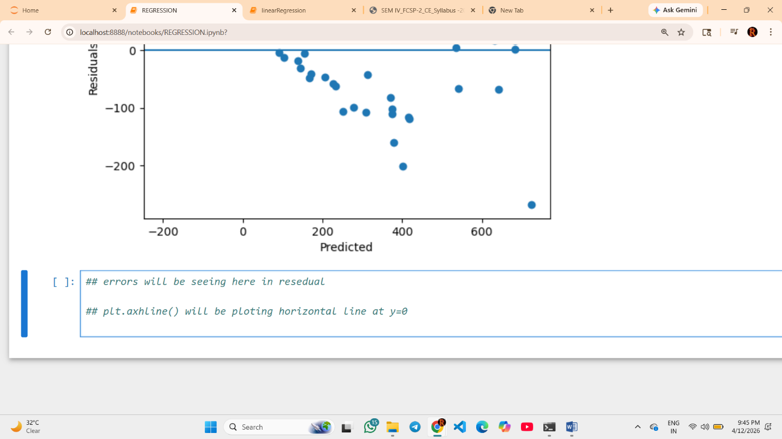

What is Polynomial Regression?
👉 Polynomial Regression is an extension of Linear Regression where the relationship between input (X) and output (Y) is not a straight line but a curve.

🔹 Equation of Polynomial Regression
y= b0+b1x+b2x2+….+bnxn

✔ Meaning:
- x2,x3x^2, x^3x2,x3 → allow the model to capture curves
- Higher degree → more flexible model

🔹 Why Do We Use Polynomial Regression?
👉 Because real-world data is often non-linear

🔥 1. When Linear Regression Fails
If data looks like:
- Curve 📈
- U-shape
- Parabola
👉 Linear regression (straight line) ❌
👉 Polynomial regression (curve) ✅

🔥 2. Better Accuracy
- Captures complex relationships
- Reduces error compared to linear model

🔥 3. Fits Real-World Problems
Examples:
- Growth rate
- Temperature changes
- Stock trends
- Biological data

🔹 Example

📌 Linear vs Polynomial
- Linear:
y=2x+5y = 2x + 5y=2x+5
- Polynomial:
y=2x+3x2+5y = 2x + 3x^2 + 5y=2x+3x2+5
👉 Second one can fit curved data better

🔹 Graph Understanding
- Linear → Straight line
- Polynomial → Curved line

What is poly.fit_transform() and poly.transform()?
These come from:
from sklearn.preprocessing import PolynomialFeatures

🔹 1. fit_transform() (Used on Training Data)
x_poly_train = poly.fit_transform(x_train)

✔ What it does:
👉 It does TWO things:

1. fit()
- Learns how to create polynomial features
- Example: degree = 2 → create x2

2. transform()
- Converts data into polynomial form

📌 Example:
If:
x_train = [[2], [3]]
After:
poly.fit_transform(x_train)
Output:
[[1, 2, 4],
[1, 3, 9]]
👉 Columns:
- 1 (bias)
- x
- x²

2. transform() (Used on Test Data)
x_poly_test = poly.transform(x_test)

✔ What it does:
👉 Only transforms, does NOT learn again
Function |  |  |  |  |  |  | Purpose |  |  |  |  |  |  | Use On
fit_transform() |  |  |  |  |  |  | Learn + convert |  |  |  |  |  |  | Train data
transform() |  |  |  |  |  |  | Only convert |  |  |  |  |  |  | Test data

POLYNOMIAL REGRESSION EXAMPLE :::
